Dog Training Collar
User Manual

Thank you for choosing our dog training products. You and your pet deserve a companionship that include memorable moments and shared understanding together. Our mission is ensure your pet’s safety by providing you with the tools and techniques to successfully train your pet. If you have any questions. Please contact our customer service.

IMPORTANT Safety Information
WARNING

Not for aggressive dogs. DO NOT USE this product if your dog is aggressive. Or if your dog is prone to aggressive behavior. Aggressive dogs can cause severe injury and even death to their owner and others. If you are unsure whether this product is appropriate for your dog. Please consult your veterinarian or certified trainer.
The Remote training collar MUST be used only for healthy dogs. We recommend you take your dog to a veterinarian before using the collar if he is not in good health.

Please use the lowest level of static shock and vibration for at the beginning to train your dogs. Make sure the level is at the lowest setting on the remote for the first use.

CAUTION
Risk of skin damage. Please read the follow the instructions carefully in this guide. Proper fit the collar is important. Because a loose collar may cause inconsistent performance. A collar worn for too long or made too tight on the pet’s neck may cause skin damage. Ranging from redness to pressure ulcers (commonly known as bedsores)
-Avoid leaving the collar on the dog for more than 12hours per day.
-Try to re-position the collar on the pet’s neck every 1 to 2 hours
-Check the fit to prevent excessive pressure. Follow the instructions in this manual.
-Never contact a lead to the electronic collar. It will cause excessive pressure on the contacts.
-Wash the dog’s neck area and the contracts of the collar weekly with a damp cloth.
-Examine the contract area daily for signs of rash or a sore.
-If a rash or sore is found. Stop using the collar until the skin has healed.
-If the condition persists beyond 48hours. See your veterinarian.
These steps will help keep your pet safe and comfortable. Millions of pets are comfortable while they wear stainless steel contacts. Some pets are sensitive to contact pressure.You may find after some time that your pet is very tolerant of the collar. If so. You may relax some of these precautions. It is important to continue daily checks of the contact area. If redness or sores are found. Discontinued use until the skin has fully healed.

Remote Definitions

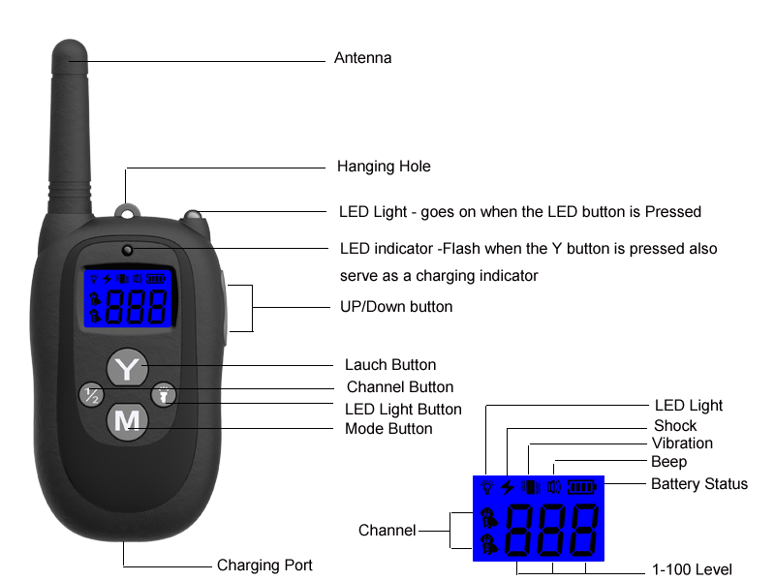
*Tips: Press “M” button 2seconds to turn on the remote. Press “M” button for 3seconds to turn off the remote.
*Tips: It will be turn off the Back-light at 10 seconds and turn off the LCD display at 2minutes.

Receive Collar Definitions

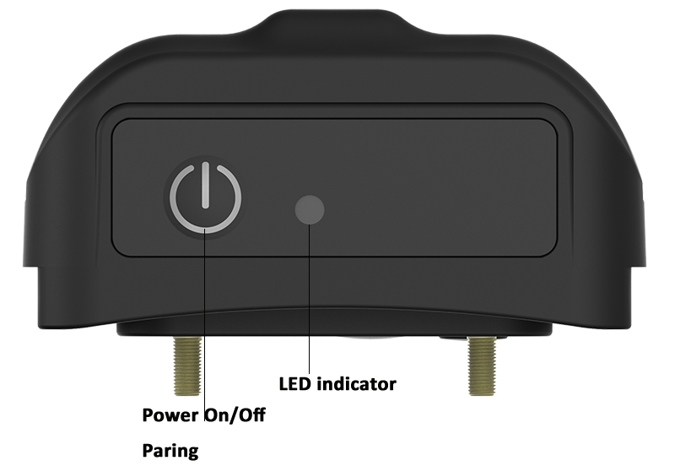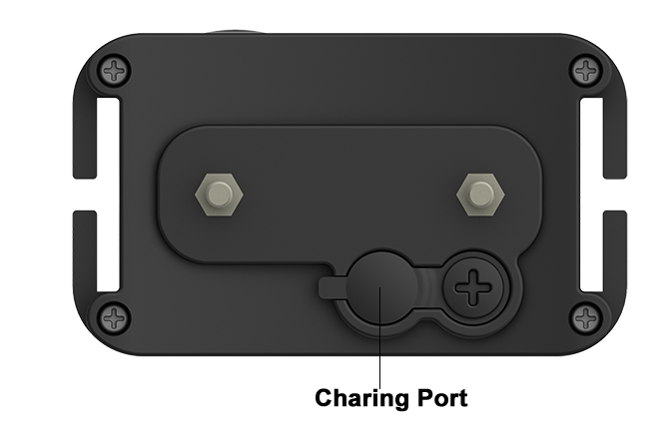

Power on/off button: Press the button 2seconds to turn on the receiver with a vibration. and press 3seconds to turn off the receiver with a beep.
Charging Port: Fully charge will take 3-4hours.
LED indicator:
Fast Blinking  1s 2times | Slow Blinking  1s 1time | Solid
Light Mode | Lower Power Or  Paring Mode | System Ruining  Or  Fully Charge

Tips:
- when the receiver is low power. The LED indicator will slow blinking.
- When the system is working or fully charged. The LED indicator will be solid
- The receiver will go to power saving mode 1minute if no movement and transmit signal.

Setup Procedures:
- Charge the remote and receiver
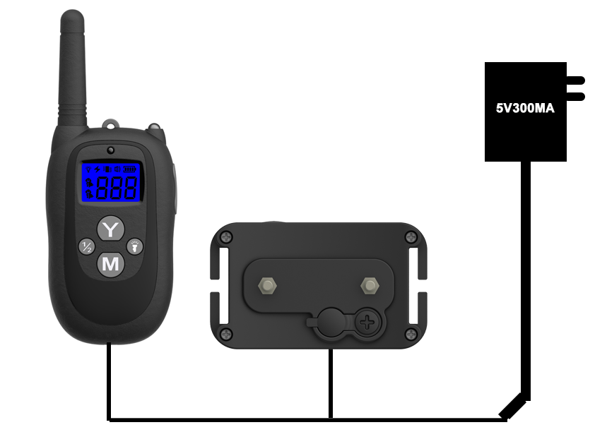

Please fully charge the remote and receiver before you use the products.
Remote: Fully charged. The RED LED will become solid
Receiver: Fully charged. The Blue LED will become solid (The LED will be blinking if Low Power)
The charging time takes around 3 to 4 hours. Both Red LED on the remote and receiver will be slow blinking when charging.
- Paring and Test the Remote and Receiver (important)
-Turn on the Remote by holding and pressing the “M” button for 2 seconds.
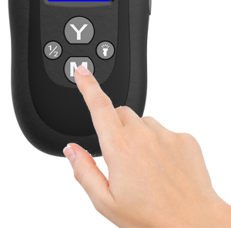
-Press and hold the power button on the receiver at least 5 seconds Then it will vibrate and then beep and go to the paring mode. Now you will see the Blue LED is flashing. (you will have 30seconds to paring the device)
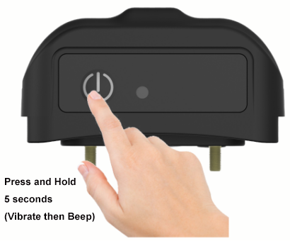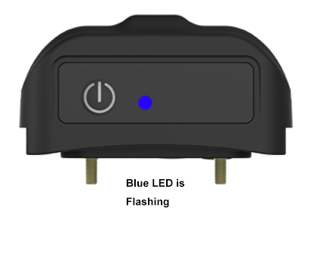
-Press the “Y” button on the remote to finish the paring then you will hear a “beep”
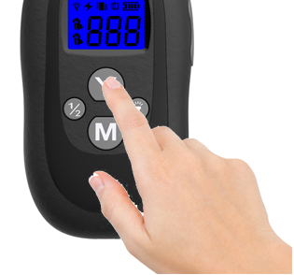
Tips: You can choose channel 1 or channel 2 to pair the remote and device. The system can pair 2 receivers at the same time. If you can not pair the device successfully. It maybe caused by the signal interference. Please change to another place to try or contact with your seller.
if you bought the dual receivers version. Follow “Setup Procedures” above to pair with another receiver (Choose another channel by pressing the “1/2” button on the remote).
The remote and receiver will go to sleeping mode if you don’t use it for 2 minutes. Any movement on the receiver will active the collar. and any button you press on the remote will active the remote.
Static Shock Test:
-Secure the included test Bulb Kit and wind its metal wire on the Receiver Collar’s Contact Points
-Press “M” to choose Shock mode . And press “Y” to test the function
-Adjust the “+””-” button on the right side of the remote to adjust the static shock level
-The test Bulb will light up indicating that the Static Shock Stimulation works
-The higher the Static Shock Level is the brighter the light should be
Important! The more higher Level the more higher Static Shock. Recommend to train your dog at lower level at the beginning.

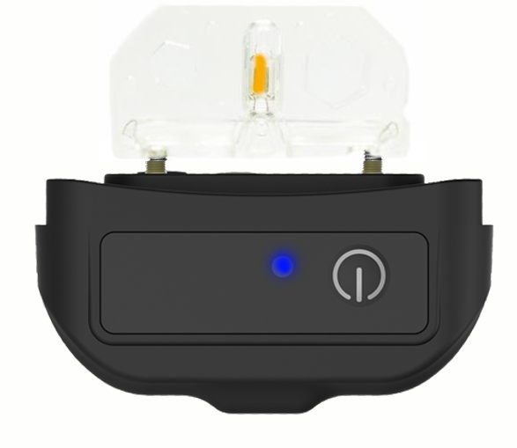
Vibration Test:
-Press “M” to choose vibration mode . And press “Y” to test the function.
-Adjust the “+””-” button on the right side of the remote to adjust the static shock level
-The Receiver Collar will vibrate indicating that the Vibration Stimulation works
Important! The more higher Level the more higher vibration. Recommend to train your dog at lower level at the beginning.
Follow above steps to test the light mode and beep mode.
Tips: the level of the light and beep mode can NOT be adjusted. Only Level 0 is set by default.

- Fit the Collar Receiver
The proper fit and placement of the collar is important for effective training. The contact points must have direct contact with your pet’s skin on the underside of the neck.
To assure a proper fit. Please follow these steps:
-Make sure that the collar is turn off
-Have your pet standing comfortably (3A)
-Place the collar receiver on your pet’s neck close to the ears. Center the contact points underneath your pet’s neck to touch the skin (3B)
-The collar should fit snugly. Yet loose enough to allow one finger to fit between the strap and your pet’s neck (3C)
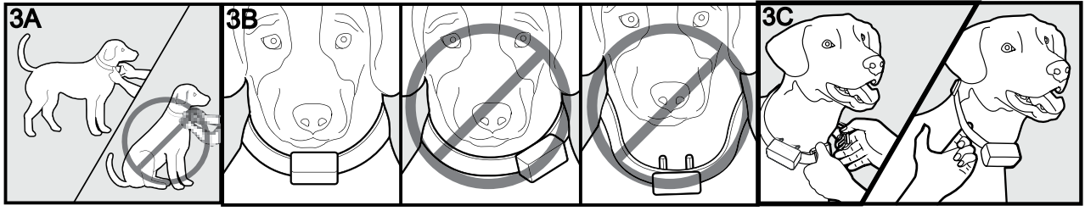
Tips:
Sometimes you need to trim the hair around the contact point to make sure that contact is consistent.
DO NOT Shave the pet’s neck as this may increase the risk of skin irritation.
Check the fit again as your pet becomes more comfortable with the collar.

- FREQUENTLY ASKED QUESTIONS
1. Is the Receiver Collar waterproof?
Yes, the Receiver is fully waterproof
- Is the Remote Transmitter waterproof?
No, the Remote Transmitter must be kept away from water
3.How long can I continuously deliver Vibration or Static Shock to my pet?
The max amount of time you can deliver the Vibration or Static Shock to you dog
continuously is 10 seconds. Then the remote will go to protection mode.
4. What should I do if my dog’s neck becomes red and irritated?
Stop using the product immediately for at least 48 hours. If the condition persists
beyond 48 hour please consult your veterinarian.
5. Can I attach a leash to the Receiver collar?
No, this can result in pulling the contact points to tightly against your dog’s neck. Use a
separate collar when needed
6. When should I recharge the Transmitter and Receiver Unit?
Remote Transmitter: The low battery symbol will appear at the bottom of the LCD
screen.
Receiver Collar: The blue LED will be fast blinking when the power is low

- Reference size for different dogs

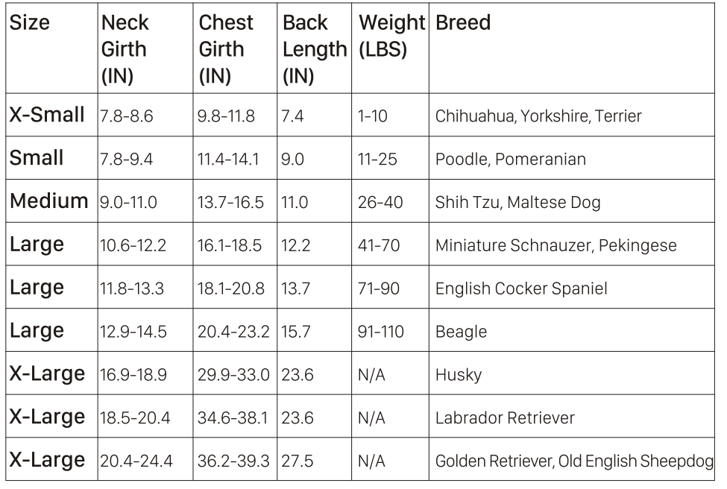

Made in China
P9BC-V3

